**Learner’s Academy**

# Project Details

**Background of the problem statement:-**

Learner’s Academy is a school that has an online management system. The system keeps track of its classes, subjects, students, and teachers. It has a back-office application with a single administrator login.

The administrator can:

● Set up a master list of all the subjects for all the classes

● Set up a master list of all the teachers

● Set up a master list of all the classes

● Assign classes for subjects from the master list

● Assign teachers to a class for a subject (A teacher can be assigned to different classes for different subjects)

● Get a master list of students (Each student must be assigned to a single class)

There will be an option to view a Class Report which will show all the information about the class, such as the list of students, subjects, and teachers

The goal of the company is to deliver a high-end quality product as early as possible.

At First it will ask for username and password of Administrator. Both are case sensitive.

Username 🡺 admin.

Password 🡺 admin.

**Operations Provided:-**

* **To add new Student**:

The Option is provided to add the new student in your learner academy. This will take following parameters as input

* Student First Name
* Student Father Name
* Student Mother Name
* Student Last Name
* Student Date Of Birth in format (DD MM YYYY)
* Student address
* Student City
* Student Class

This will add the student of such properties in your database.

* **To add new Class:**

This Option will add new Class to your learner academy. This Option only take the

***class name as parameter*** to register the class.

* **To add new Teacher**:

This Option will add new Teacher In your academy. It takes only one parameter i.e.

**Teacher Name**.

* **To add new Subject**:

This option will add new subject to teach to student of your learner academy. It takes three Parameter to add the Subject.

🡺 Subject Name.

* Class that is already present in your learner academy.
* Teacher of your learner academy to teach the particular subject.
* **To view the List of any of the above entity**:

Means there are option to view the list of Classes, Subjects, or Students present in your learner academy.

* **To get the class Report of specific class:**

This will give the master list of the selected class which includes: -

* Subject and Teacher for Specific Subjects.
* Student in Selected Class.

I Have given Screen Shots as example of performing above operations and also given link to the GitHub repo. Wish to have a glimpse on repo which will definitely clear any doubt you have about this program.

Thank You for giving your precious time for reading this Hope you will not have any problem while executing this program.

# Sprint Planning

**Tasks and Test scenarios:-**

## Sprint 1 Goal: Architecture design sprint

* Come up with technologies, data model and architecture solution for the project

**Task1:** Discuss technologies, data model and architecture solution to be used for the project.

## Sprint 2 Goal: Ability for Admin to login to admin system and update password

* As an admin user, I should be able to login to admin page

**Task1:** Create a user login form for Admin to enter username and password and login

**Task2:** Add a validation when login button is clicked to verify username and password goes to database

**Task3:** Display error when login validation fails.

## Sprint 3 Goal: Ability for Admin to add class ,teachers ,Subjects , Students into the DataBase

* As an admin user, I should be able to add Class
* As an admin user, I should be able to add teachers
* As an admin user, I should be able to view list of teachers
* As an admin user, I should be able to add name of subject
* As anAdmin user, I should be able to add student information into dataBase

# User Flow Diagram

# Technologies Used:

|  |  |
| --- | --- |
| **IDE** | Eclipse |
| **Programming languages** | Java, HTML |
| **Database server** | MySQL |
| **Project** | Maven |
| **Code repository** | GitHub |
| **Web application** | JSP |
| **ORM** | Hibernate |
| **Programming language class** | Java servlets |

# Core concepts used:

* Classes
* Interfaces
* Objects
* Methods
* Annotation
* Dynamic variables
* Data types - int, string, date, float
* Access modifiers
* Getters/setters
* If else statements
* Exception handling - Try catch exceptions
* List
* Comparison and Logical operators
* Java keywords - public, private, super, try, catch, if, else, import, int, void, new
* Hibernate
  + Configuration
    - Config file: cfg.xml file
  + SessionFactory
    - Opensession
    - Closesession
  + Session
    - Session.close
    - Session.save
    - Session.beginTransaction
    - getTransaction
    - commit
    - Annotations
  + Dynamic webpages using servlet
  + doGet
  + doPost
  + request
  + response
  + dispatcher
  + getParameter
* JSP
  + Dynamic webpages using JSP

**ScreenShots**

***Login Page on starting the Program***

Username: admin

Password: admin

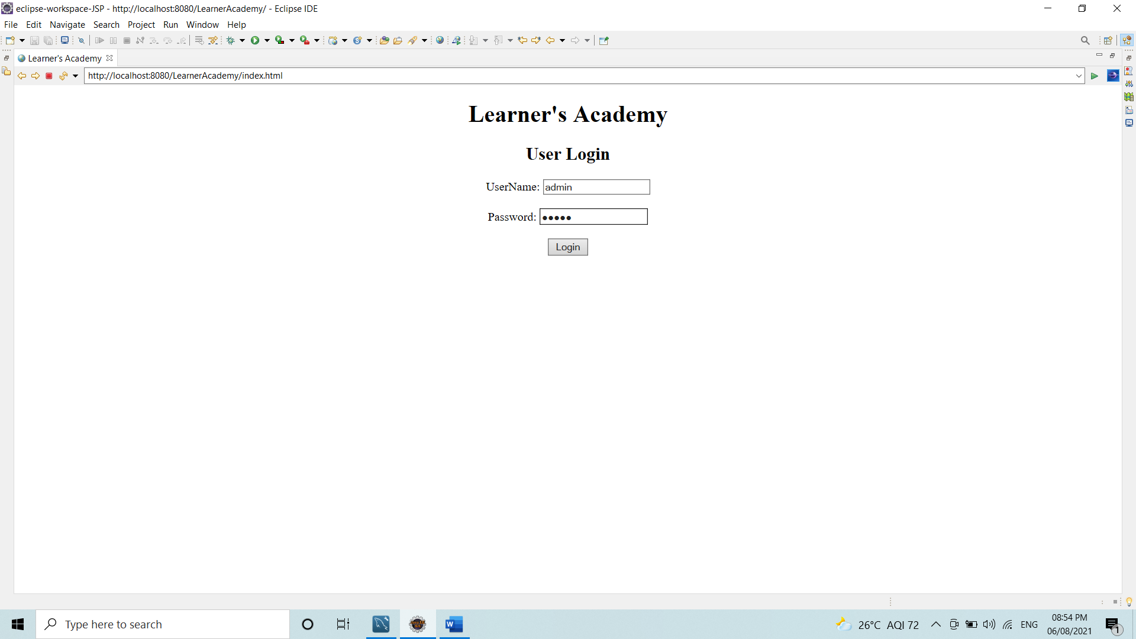

If the credentials gone wrong:

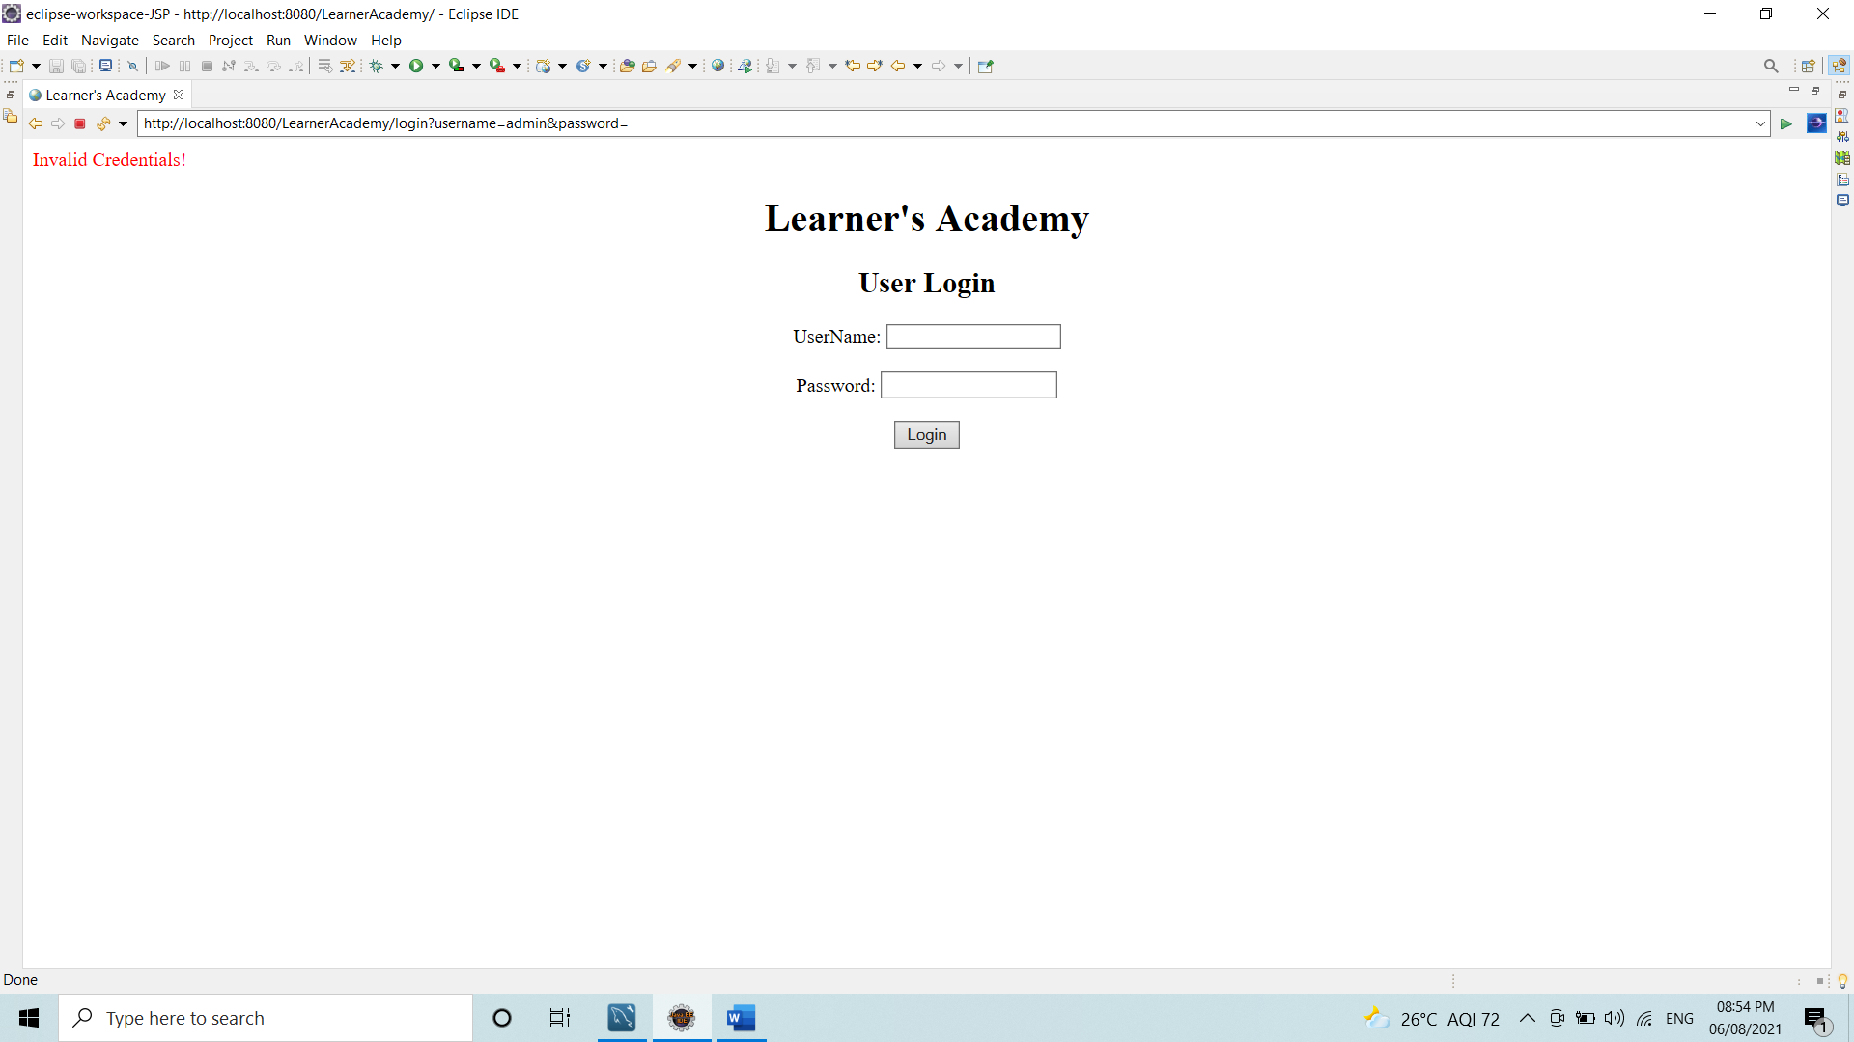

After Login with correct credentials:

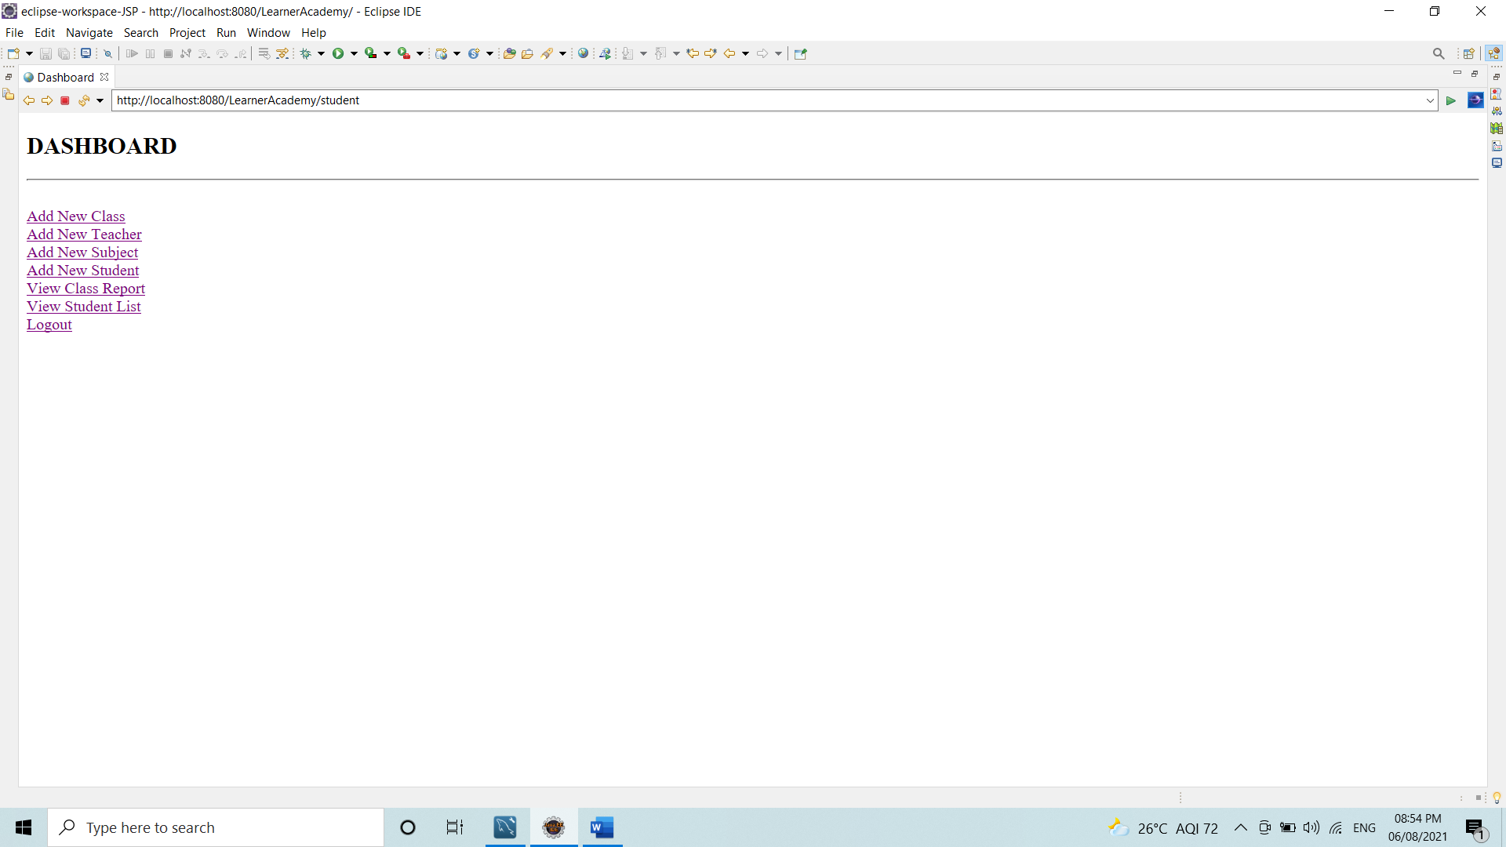

After Selecting Add New Class

It only Ask for Name of the class.

Suppose I want to register my new Class A

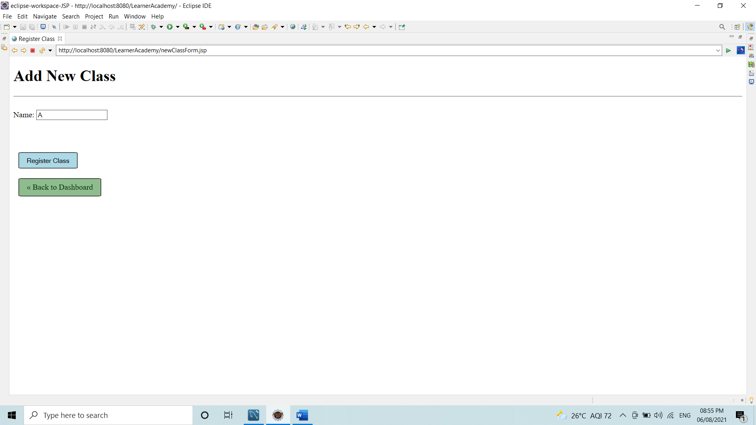

After Clicking on register class ,it add the Class A to database. If the class with same name is present it will not add the class.

If any error occurs:

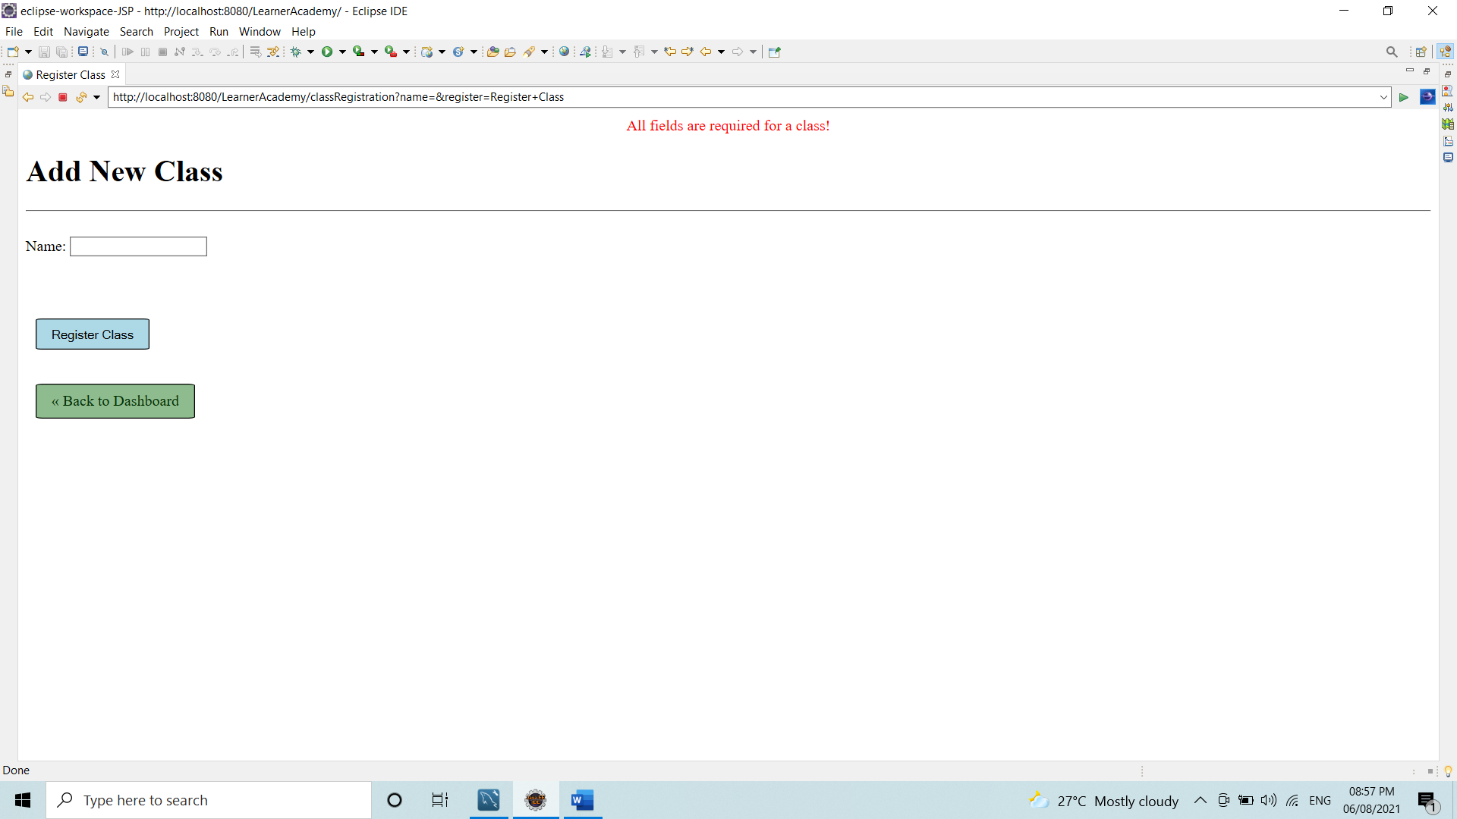

After Selecting Add New Teacher

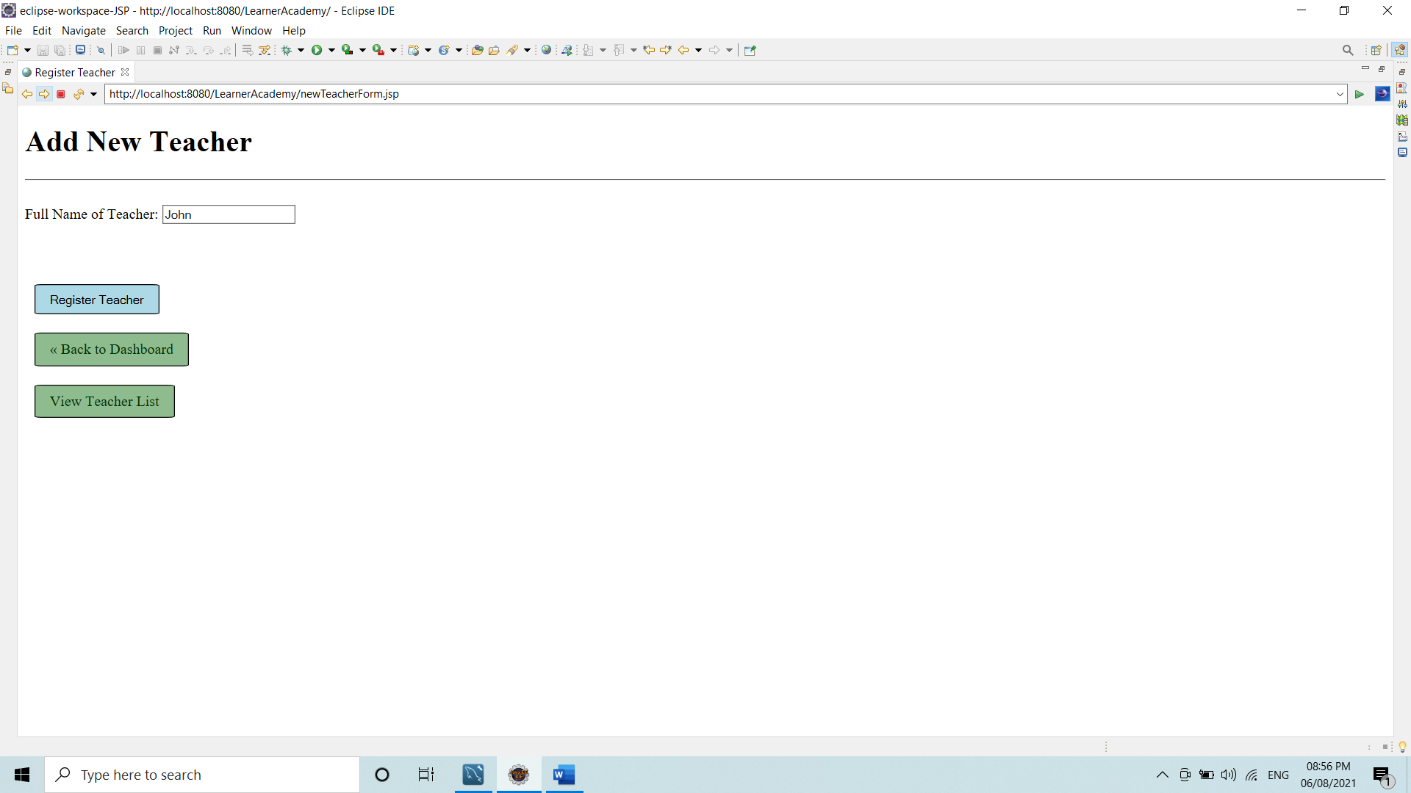

It only take name of teacher as parameter.

By clicking on register Teacher, it registers the Teacher.

After Clicking on View Teacher List:

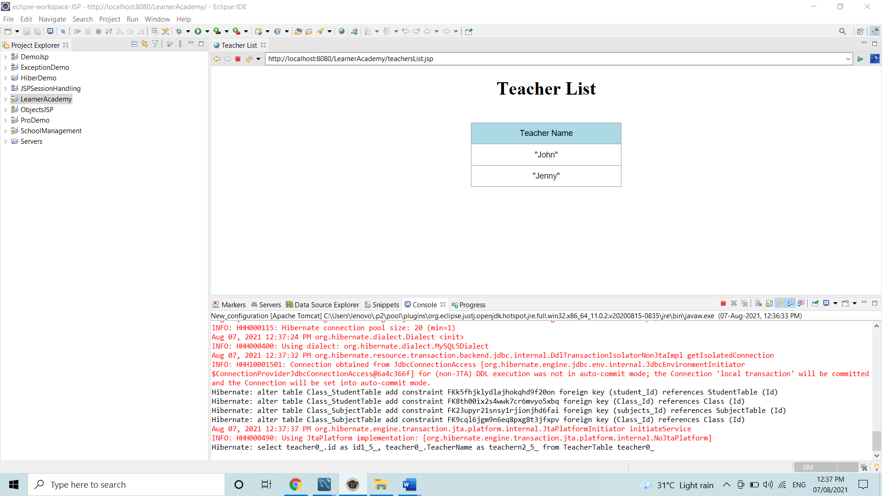

If an error occurs:

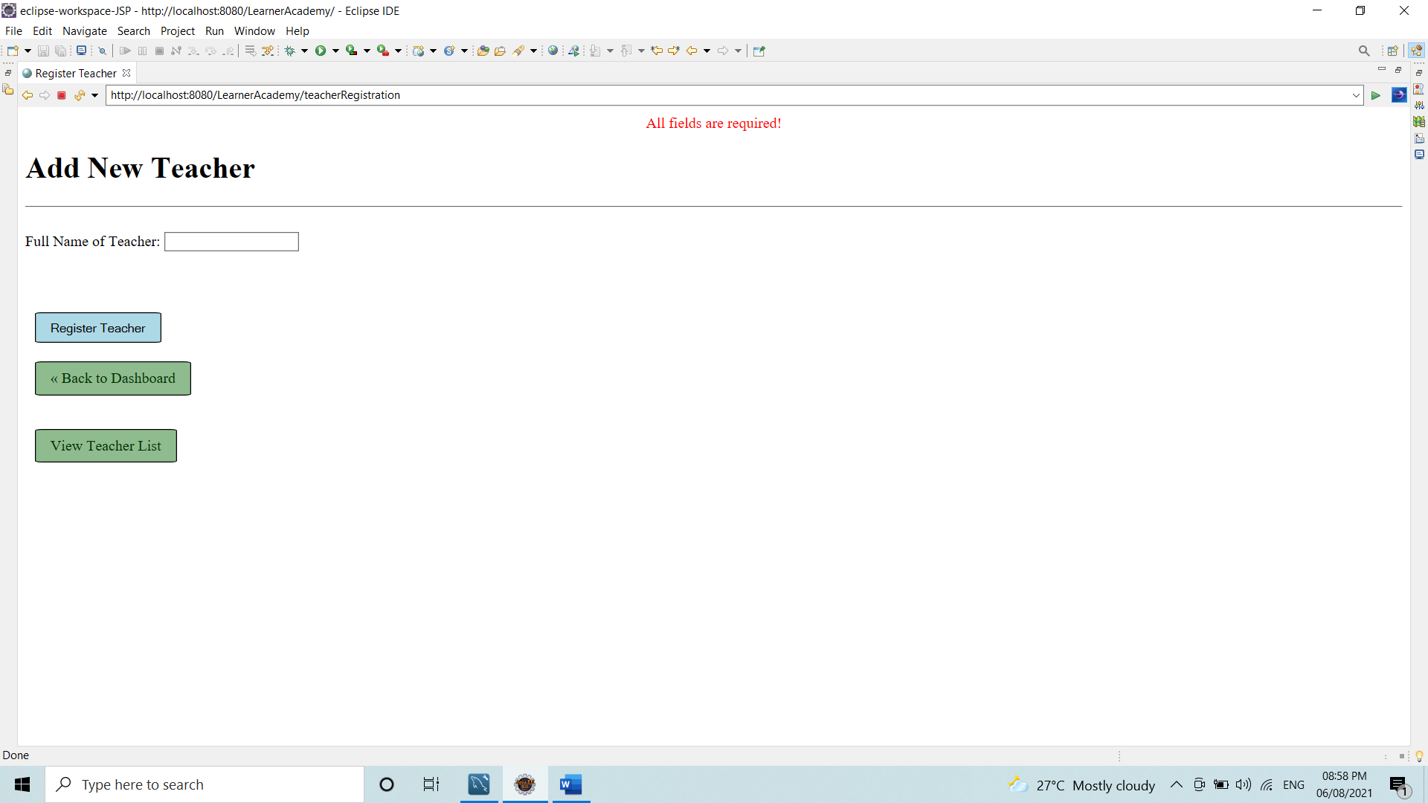

After Selecting Add New Subject

It takes 3 Parameters:

* Subject Name
* Class to which Subject is to mapped
* Teacher who will teach the subject.

There is drop down list for Class and Teacher from which you could select the present teacher and class for the subject.

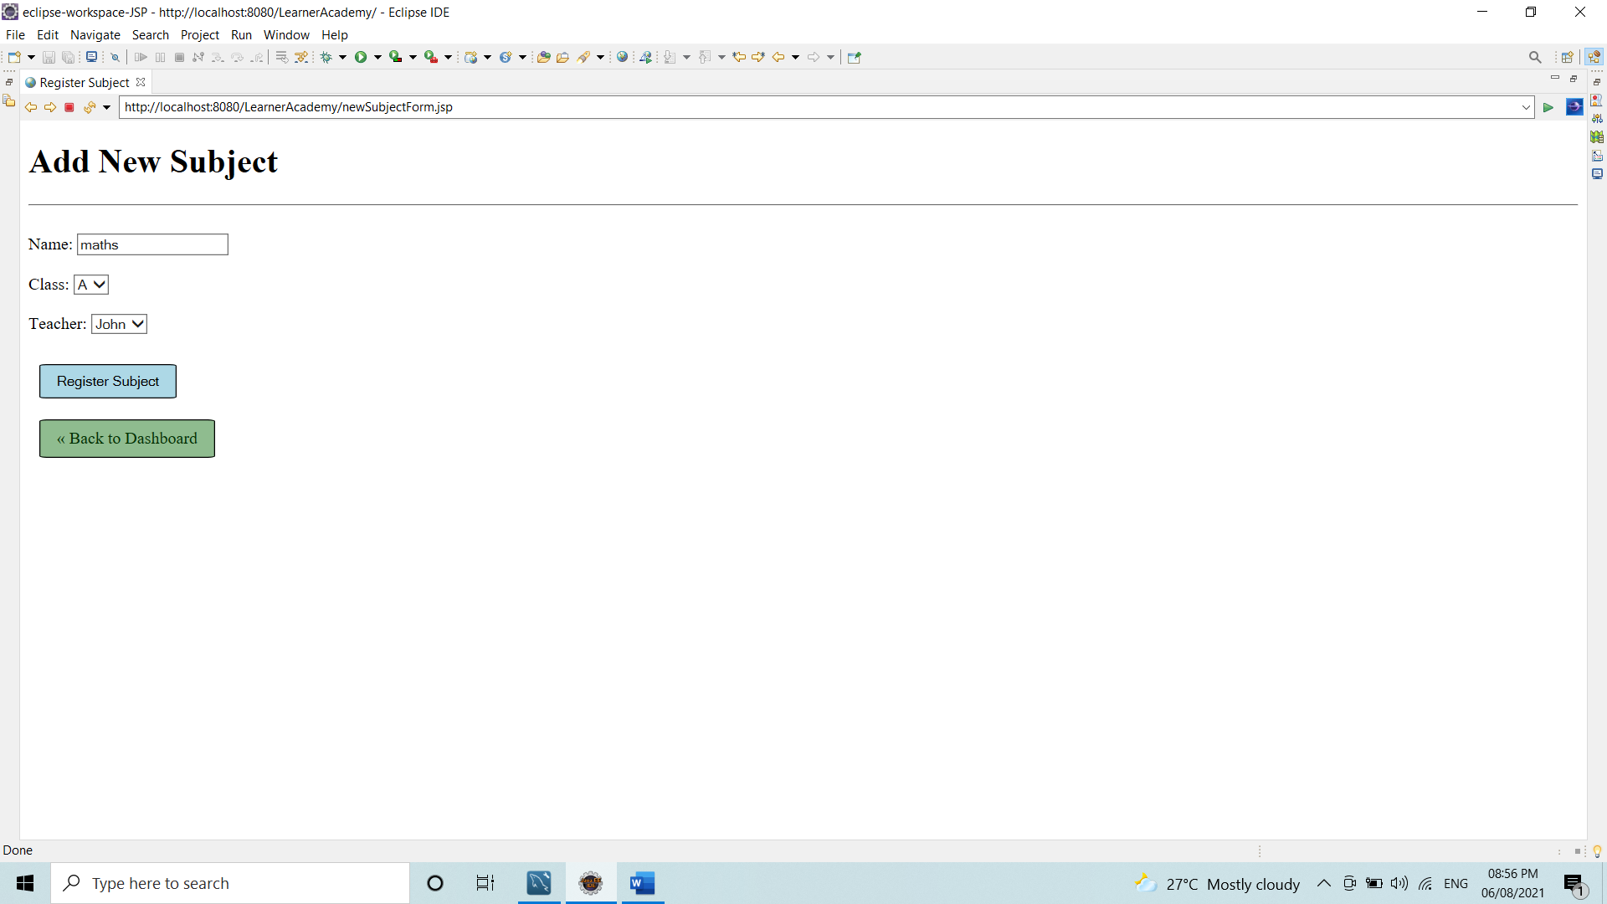

If any error occurs:

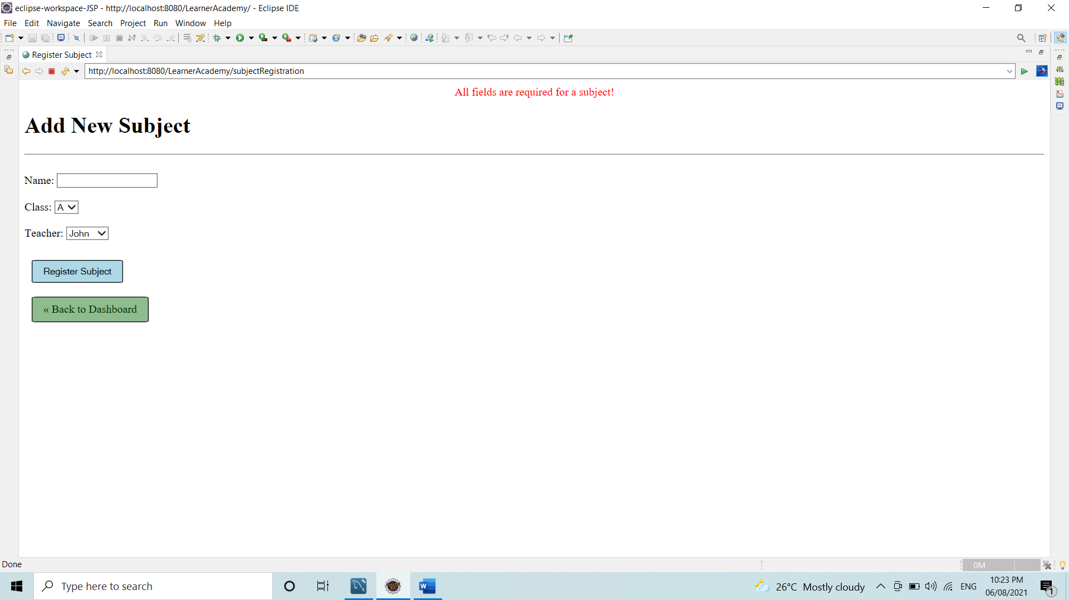

After Selecting Add New Student

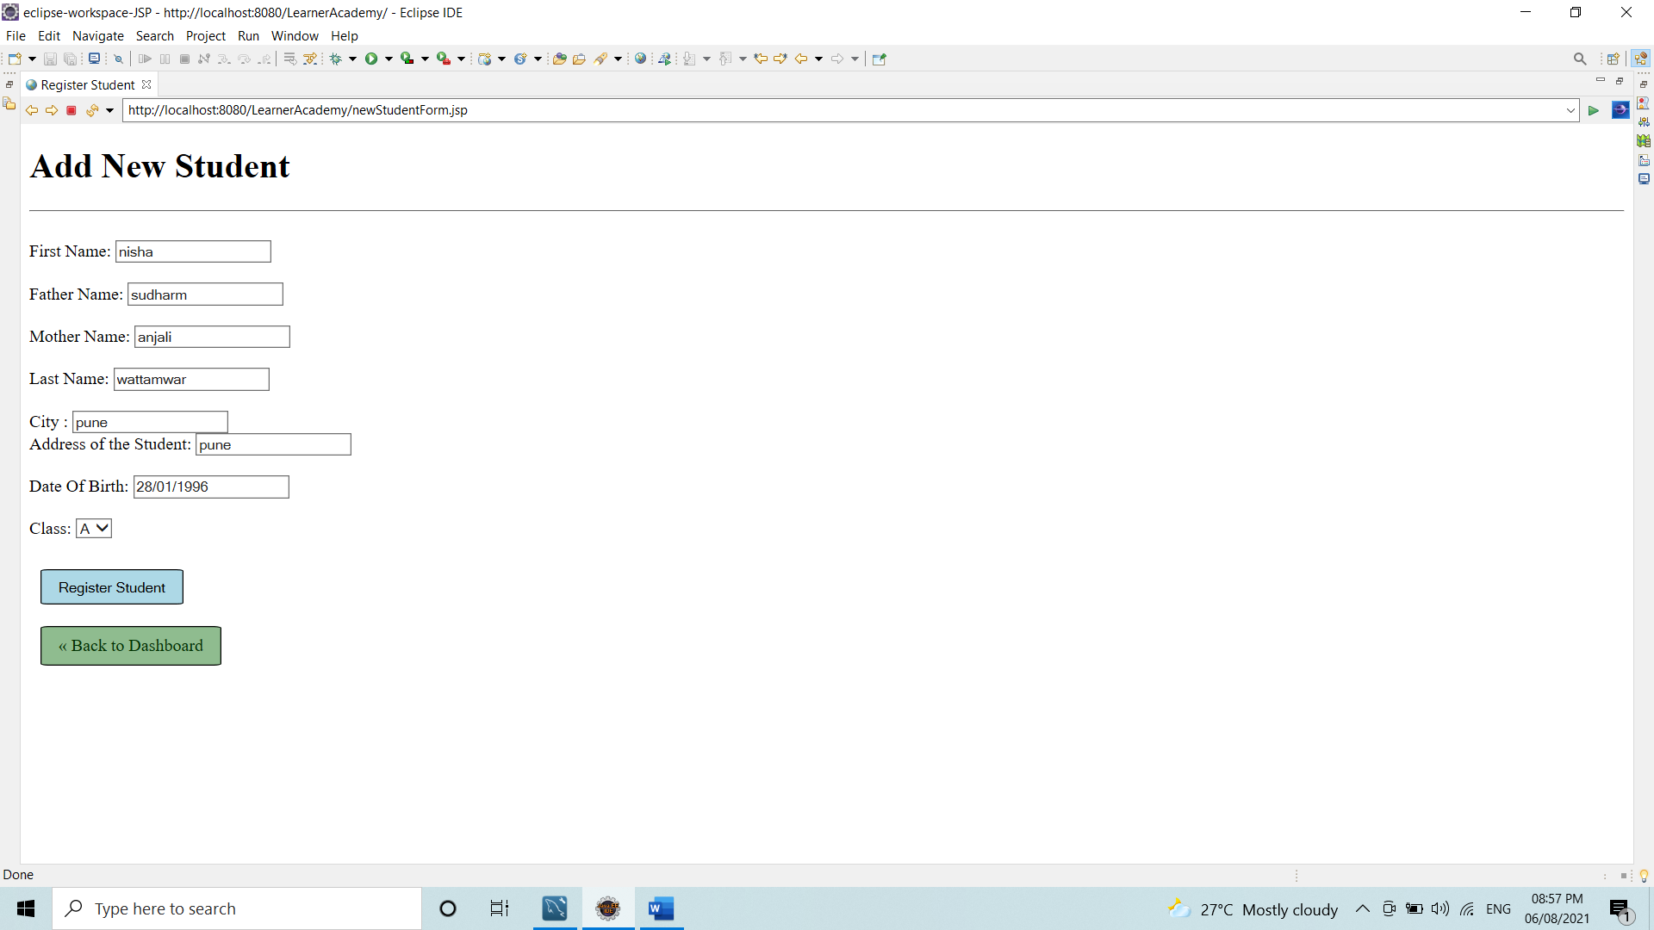

**Note:** The Date of birth format must be DD-MMM-YYYY.

If an error occurs:

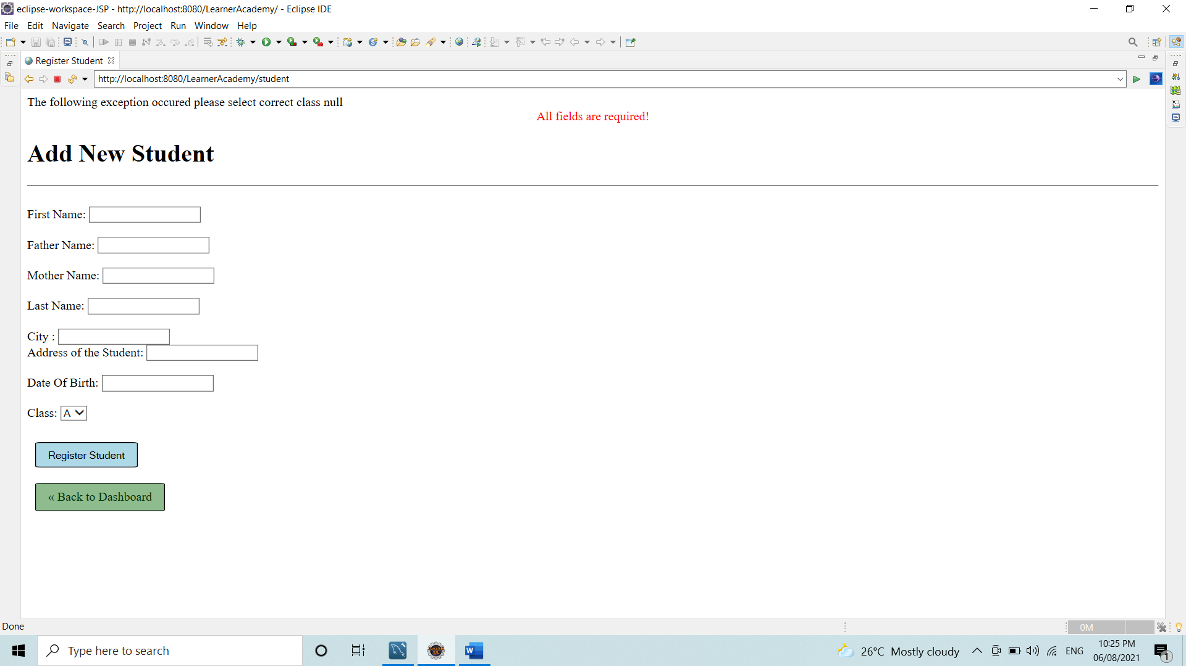

After selecting View Student List

